**Assignments on Java 11**

1. Write a program to calculate the Simple Interest with minimal code using features of Java 11.

**Code and Output:**

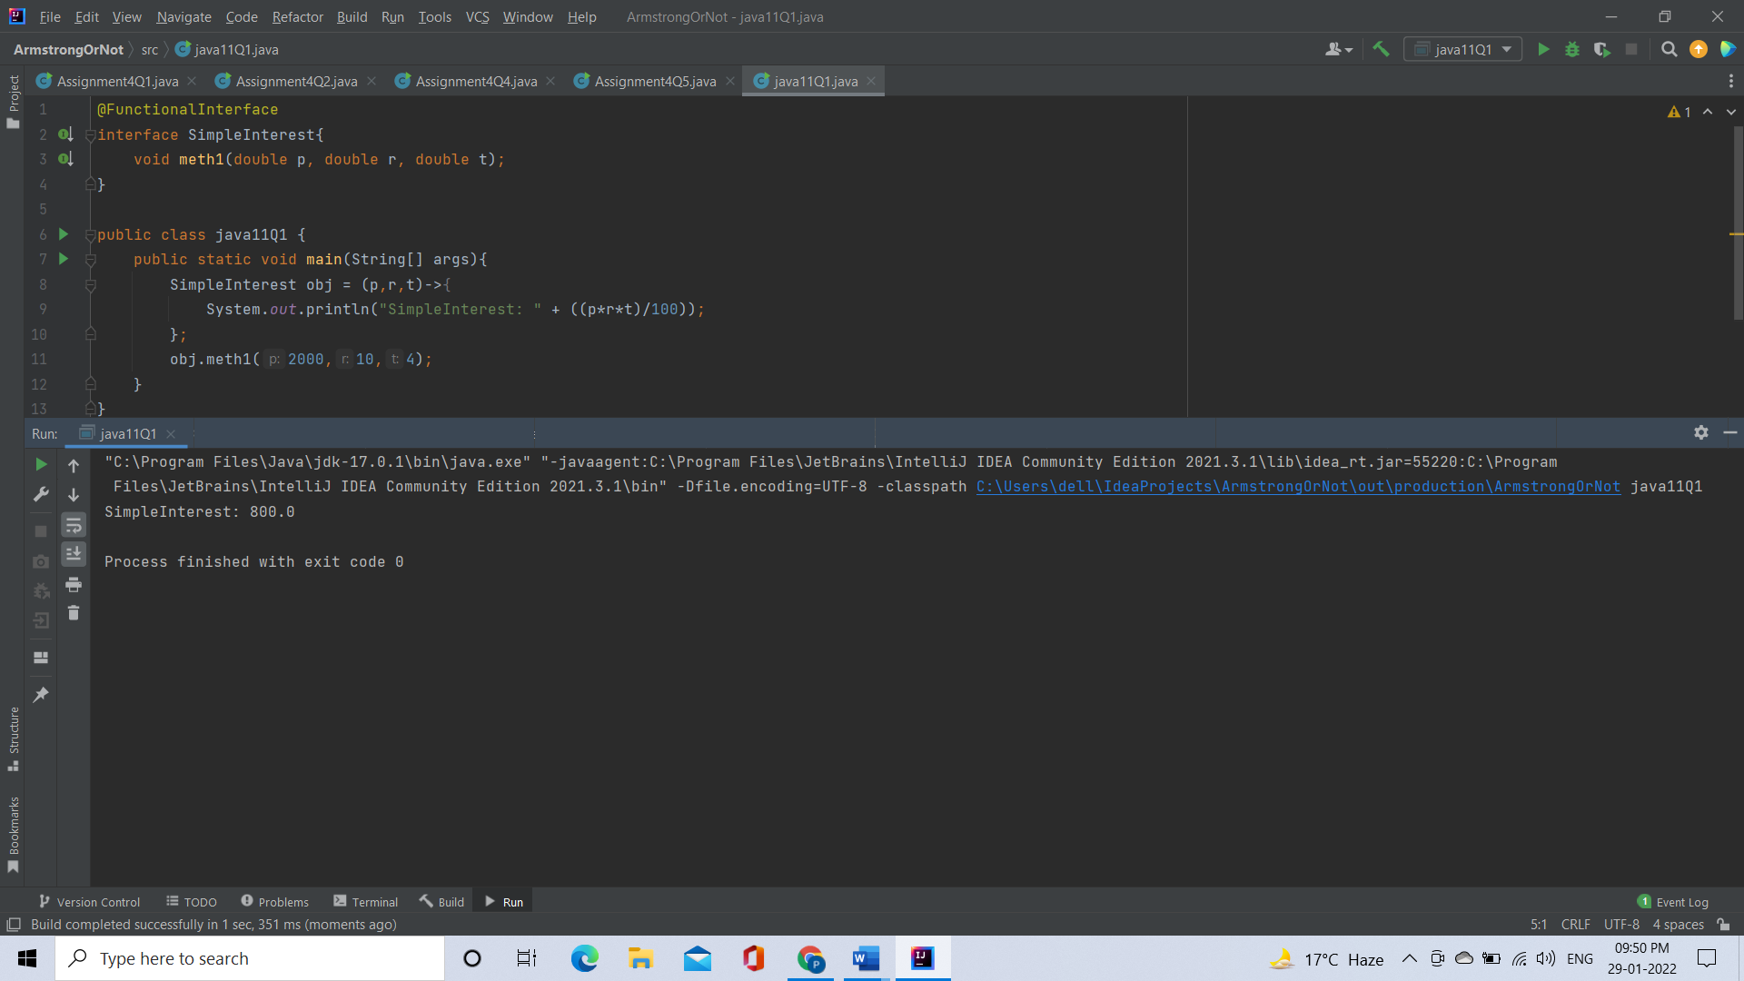

2. Java 11 supports var keyword for variable declarations. List the scenarios where var keyword cannot be used for such variable declarations. Give reason in support of your answer for each scenario.

**Answer:**

scenarios where var keyword cannot be used are:

* **var cannot be used for method parameters and return type**
* **var cannot be used with Lambda Expression.**

3. “A quick brown fox jumps over the lazy dog”. Create an ArrayList from the given String. Such an ArrayList should include each word from the given sentence. Finally convert such List to an array using Java 11 methods and print the output.

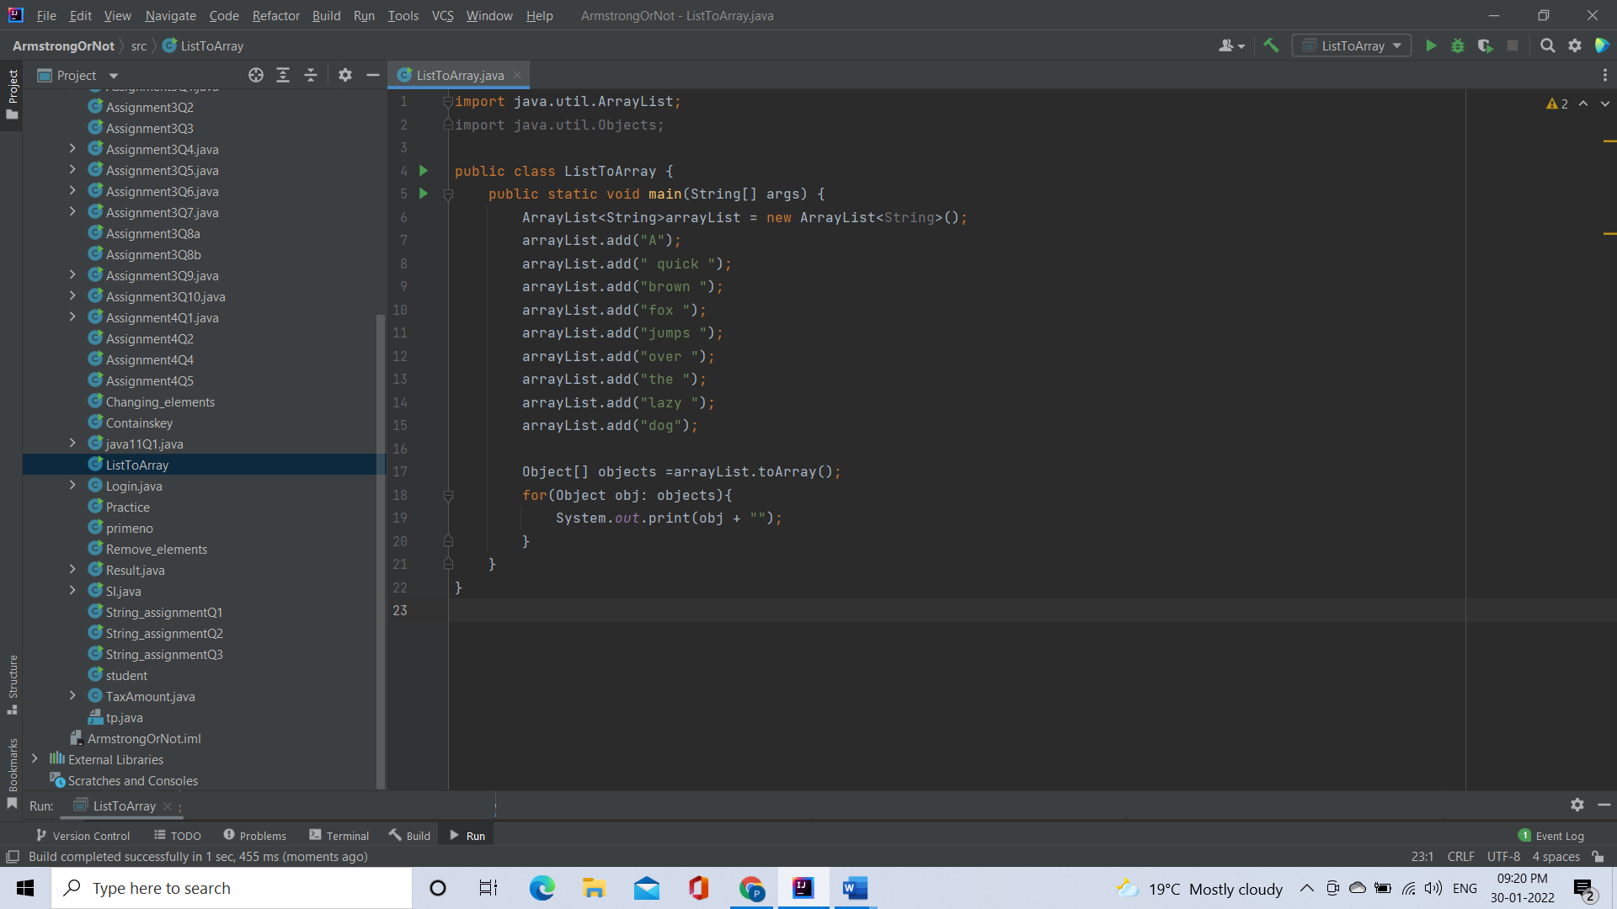

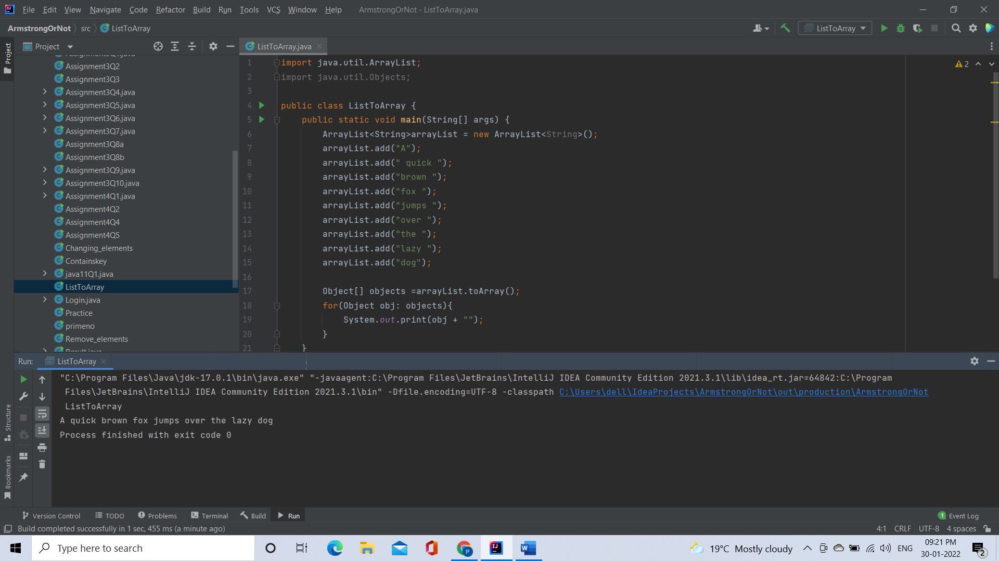

4. Using features of Java 11, read the data from a text file (File name: StudentList.txt). Calculate the count of students and print the names as well as the total count of students on the screen. (If any line in file doesn’t contain a name, for such a record blank space should not be printed in the output) Hint: Use java 11 features of files and String methods to reduce the lines of code to be written.

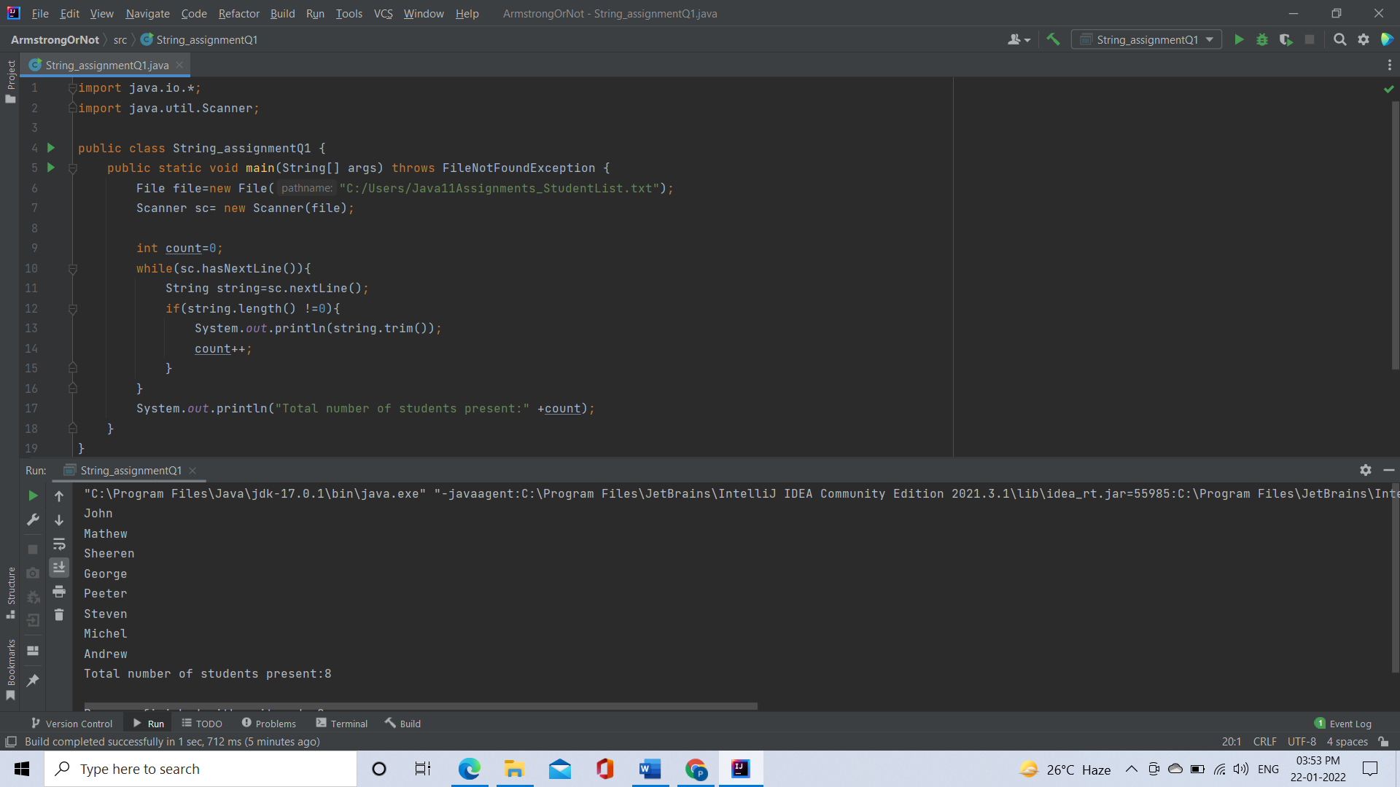

5. Write a program with menu to accept the price of certain items and display their total.

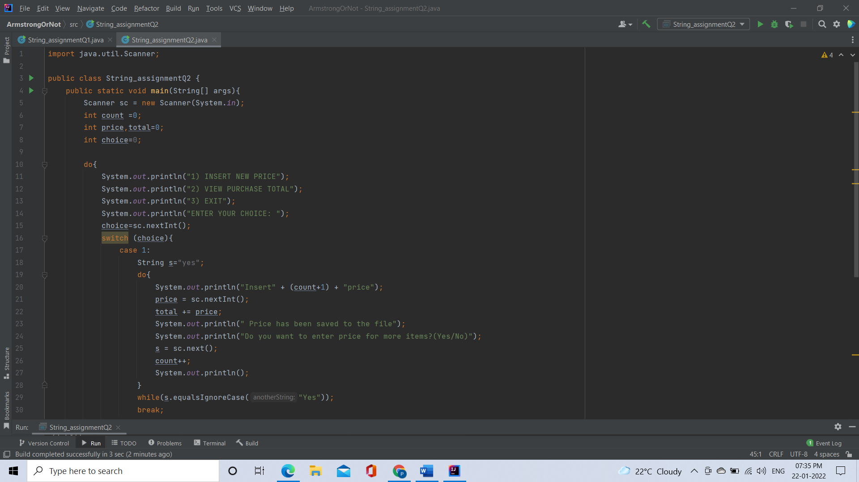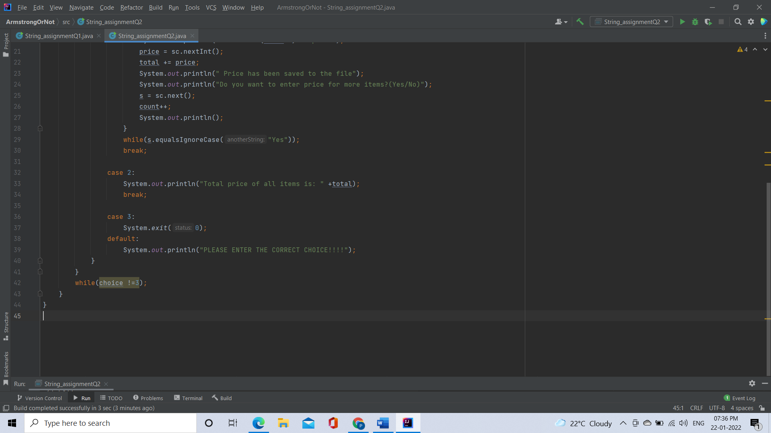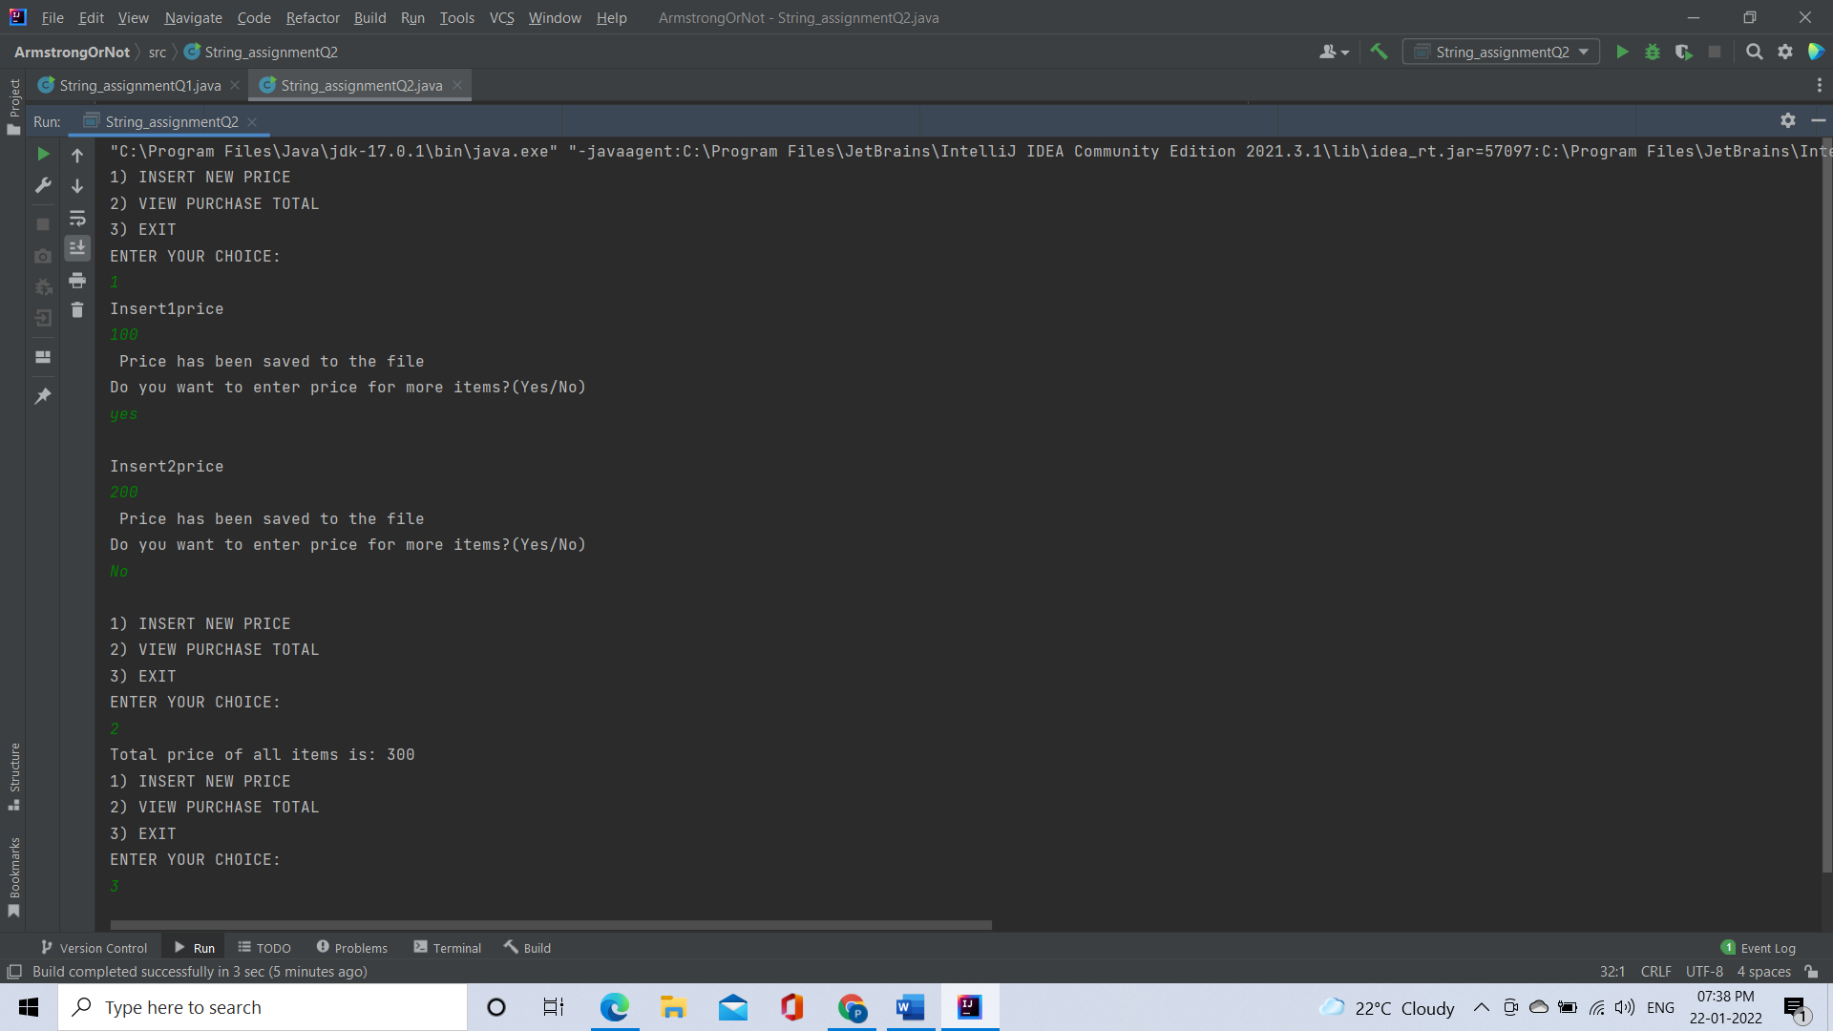

6. Write a code using HttpClient API which sends a GET request to https://httpbin.org/get, and print out the response header, status code, and body for the given URL.

